Spectrum Lecture Series 2011-2012

Fire Safety Engineering: Examples of how interdisciplinary research can solve real-world problems.

Tues., April 17th, 4:30 pm  Montgomery College  Globe Hall, HT Building,  Germantown Campus  Jason Averill  Group Leader  National Institute of Standards and Technology (NIST) | 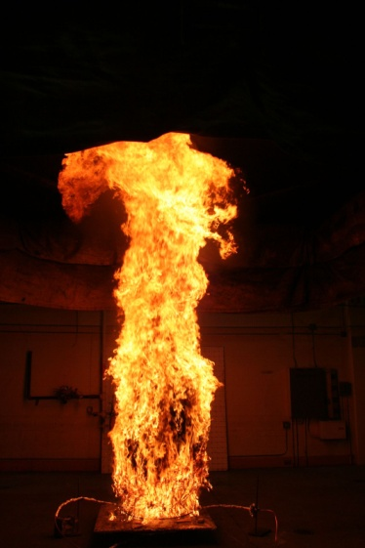
Unwanted fires are estimated to cost the U.S. economy over $350B annually, which is roughly 2.5% of the Gross Domestic Product. Mitigating this problem requires a dynamic, highly interdisciplinary approach. This talk will survey the major components of the national fire problem, discuss the basic scientific principles of combustion and fire dynamics, and then highlight the critical role of science, technology, engineering, and mathematics in enabling cost-effective solutions. Specific research projects and fire investigations from the National Institute of Standards and Technology (and other Federal agencies) will highlight how research can solve real-world problems.

Jason D. Averill is the leader of the Engineered Fire Safety Group at the National Institute of Standards and Technology (NIST). The author or co-author of more than 60 scientific works, Mr. Averill has focused his research on cost-effective risk mitigation in structures, with a focus on fire hazards. Research projects include analysis of the evacuation of World Trade Center; experiments related to the toxic potency of combustible products; and, most recently, risk modeling to quantify the effectiveness of fire department response to both residential and high-rise structure fires.

As always, Spectrum Lectures are appropriate for a general audience and admission is free. No tickets are required. For questions or to request accommodations for physical disability, please contact Susan Bontems at susan.bontems@montgomerycollege.edu or 240-567-7740. More information about Spectrum Lectures can be found at: http://cms.montgomerycollege.edu/edu/department.aspx?id=10883

